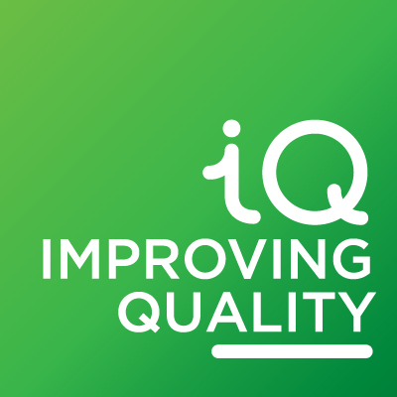
Improving Quality
Self-Assessment Workbook
Progression Level

Element 1 – Accountable

This Element describes requirements for good governance, leadership and management
Requirement | Evidence we have – it can be paperwork, the views of people or anything that shows that you meet the requirement |  | Possible sources of evidence – note that you do not have to provide this evidence, these are suggestions only
P1.1 |  |  | - Governing document  - Board meeting minutes showing the latest review of it
P1.2 |  |  | - Board meeting minutes showing discussions on good practice  - Briefing papers to the Board about legal or good practice changes
P1.3 |  |  | - Reports to the Board on progress against the Annual and Strategic Plans  - Board meeting minutes showing discussion on progress against the Plans and action
P1.4 |  |  | - Programme for reviewing polices that shows what and when  - Records of policy reviews  - Dated policies
P1.5 |  |  | - Records of Board member skills’ audits  - Board role descriptions  - Board recruitment records
P1.6 |  |  | - Analyses such as SWOT or PESTLE  - Incoming information sources  - Briefing papers  - Planning meeting minutes
P1.7 |  |  | - Documented vison, purpose, values and objectives  - Governing document
P1.8 |  |  | - Conflict of interest policy  - Register of interests  - Examples of the policy being followed

Element 2 – Welcoming

This Element is about people – involving service users, managing and developing staff and volunteers, equality and diversity, and working with others
Requirement | Evidence we have – it can be paperwork, the views of people or anything that shows that you meet the requirement |  | Possible sources of evidence – note that you do not have to provide this evidence, these are suggestions only
P2.1 |  |  | - Appraisal policy  - Appraisal records
P2.2 |  |  | - Records of identified training needs  - Records of training and development provided
P2.3 |  |  | - Feedback from staff and volunteers about internal communication  - Use of notice boards, newsletters, team meetings, etc
P2.4 |  |  | - Staff handbook  - Volunteer policies
P2.5 |  |  | - Consultation documents  - User surveys  - Other feedback information
P2.6 |  |  | - Accessibility policy  - Feedback from premise users
P2.7 |  |  | - Partnership documents such SLAs, contracts or memorandums of Understanding (MOUs)  - Records of reviews of these documents
P2.8 |  |  | - Details of relevant networks  - Network meeting notes and minutes
P2.9 |  |  | - Assessment of users’ needs  - User involvement policy
P2.10 |  |  | - Communication strategy or plan

Element 3 – Effective

This Element refers to the services that the organisation provides and the planning, delivery, monitoring, and evaluation that the organisation carries out
Requirement | Evidence we have – it can be paperwork, the views of people or anything that shows that you meet the requirement |  | Possible sources of evidence – note that you do not have to provide this evidence, these are suggestions only
P3.1 |  |  | - Up-to-date Strategic Plan
P3.2 |  |  | - Records of review and update of the Strategic Plan
P.3 3 |  |  | - Annual Plan  - Strategic Plan  - Minutes of planning meetings
P3.4 |  |  | - Records of consultations with users and organisations  - Minutes of Planning meetings
P3.5 |  |  | - List of desired outcomes  - Monitoring reports
P3.6 |  |  | - Funding agreements showing monitoring requirements  - Reports to funders
P3.7 |  |  | - List of output targets  - Monitoring against the targets
P3.8 |  |  | - Reports against plans  - Meeting minutes showing how issues are identified and action taken

Element 4 – Sustainable

This Element covers how the organisation manages risk, money and the resources used to make service delivery happen.
Requirement | Evidence we have – it can be paperwork, the views of people or anything that shows that you meet the requirement |  | Possible sources of evidence – note that you do not have to provide this evidence, these are suggestions only
P4.1 |  |  | - Latest audited or examined annual accounts
P4.2 |  |  | - Digital communication or social media policy  - Evidence of use of social media
P4.3 |  |  | - Environmental statement or policy  - Activities to reduce negative environmental impact
P4.4 |  |  | - Minutes of resource planning meetings  - Feedback from staff and volunteers about the structure and about the use of resources
P4.5 |  |  | - Training in fundraising  - Information from the Fundraising Regulator
P4.6 |  |  | - Cashflow projections  - Latest budget  - Financial reports
P4.7 |  |  | - Reserves Policy and evidence that it is being met  - Board minutes showing review of the policy
P4.8 |  |  | - Data protection policy and procedure  - Training in data protection  - Records of review of personal data kept
P4.9 |  |  | - Risk management policy  - Register of major risks  - Board minutes showing consideration of risk issues

